What is Data Structure and why?

Program = Algorithms + Data Structure.
- Data Structure : is a way of organizing all data items and their relationships to each others inside the program in order to deal with them.
- Data Structure : affects the design of both structural and functional aspects of the program.
- Data structure : is how u organize, manage and store data for efficiency reasons.
- A data structure: is not only used for organizing the data. It is also used for processing, retrieving, and storing data.
Various types of data structures have their own characteristics, features, applications, advantages, and disadvantages.
Int, float, string, struct, array,..etc. all of them is a Data Structure

Data Structures (DS) vs Database (DB)
Data Structure : In computer Programming, Data structure is a way of organizing and storing data so as to ease the accessing and modification of data.
Database: is a collection of data that is stored in an organized fashion in a table containing rows and columns using a software package known as Database Management System (DBMS).
DBMS is used to modify, define, manipulate and manage data. Some examples of DBMS are : MySQL, Oracle Database and Microsoft Access.
Some commonly used data structures are Array, Linked List, Stack, Queue, Heap, Binary Tree and Graph.
Data in data structure is stored In RAM inside the program.
Structured query language (SQL) is used to perform operations on the data in Database.
Programming languages C++, Java, Python are used to perform operations using data Structures.
Example Of DBMS : MySQL, Oracle, MongoDB, Sybase , SQL Server, Access, etc.

Classifications of Data Structures
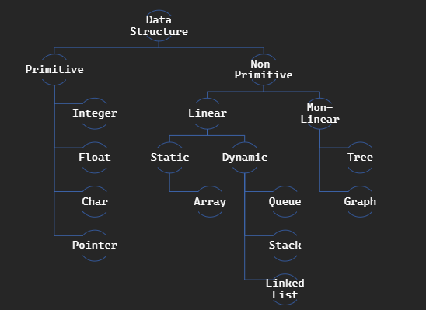

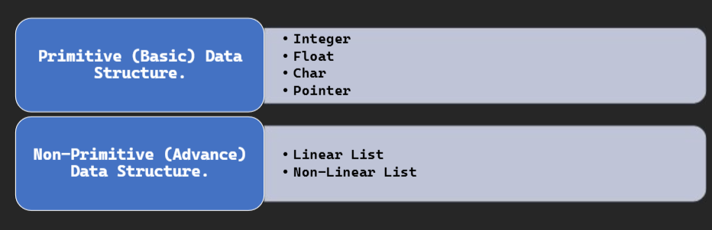
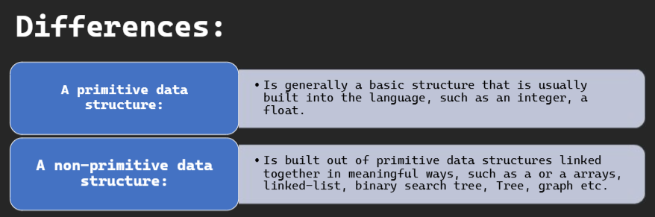
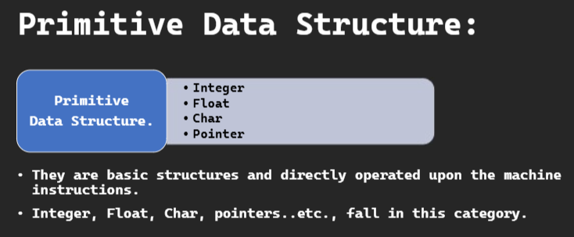

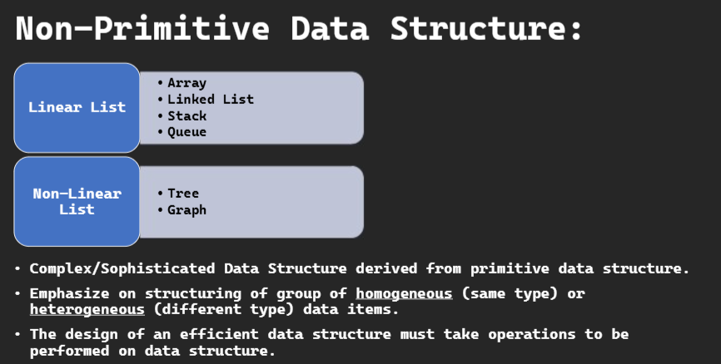
Linear List: تقدر تمشي فيهن ب فور لوب
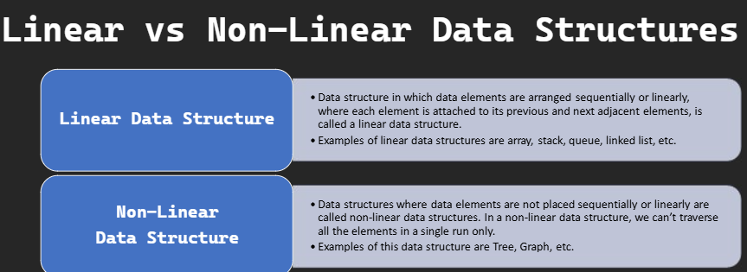
Non-Linear List : ما تقدر تمشي فيهن ب فور لوب( نستعمل بوينترز)
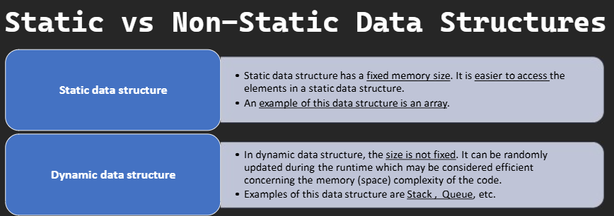
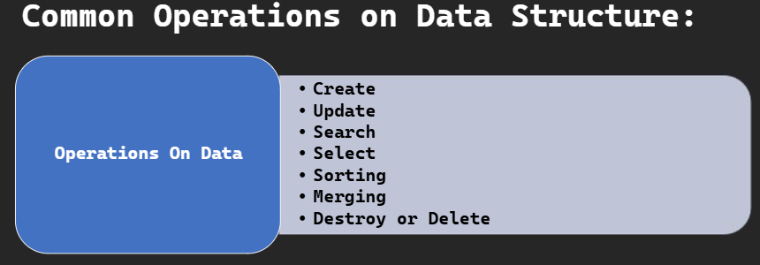

Time & Space Complexity - Big O Notation – Part 1

Things Affect Program Speed & Efficiency
- What Affects Program Speed?
Hardware (CPU, RAM)
Operating System
- What affects Algorithm?
Time
Space
- Performance has to do with?
Hardware , OS
- Complexity has to do with?
Time Complexity
Space Complexity

Big O Notaion
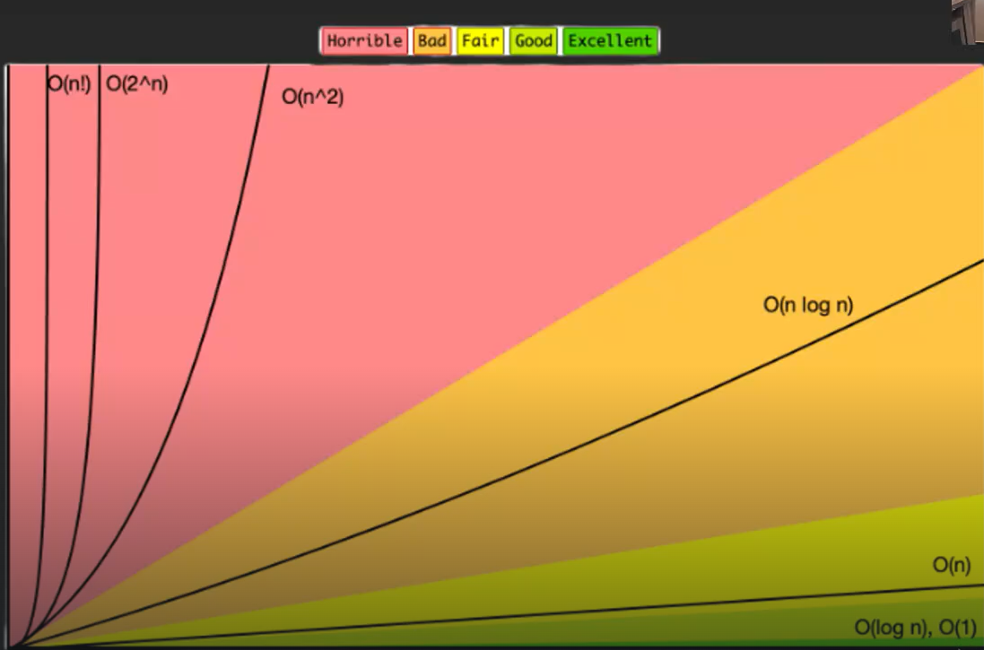

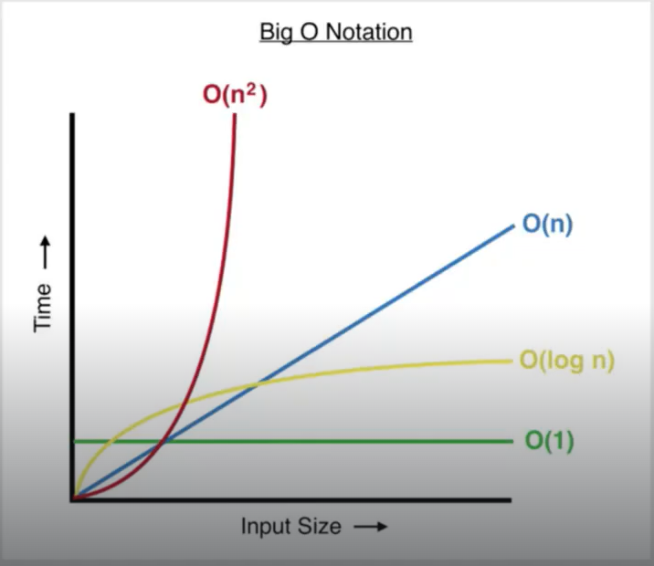
- An algorithm's time complexity: specifies how long it will take to execute an algorithm as a function of its input size.
- An algorithm's space complexity: specifies the total amount of space or memory required to execute an algorithm as a function of the size of the input.
- The big-O originally stands for “Order Of“.
- Big O tells us about the Efficiency of Algorithm.
- Big O, also known as Big O notation, represents an algorithm's worst-case complexity.
- Big O uses algebraic terms to describe the complexity of an algorithm.
- Big O describes the relationship between Input Size and Time/Space.
- Big O does not tell you the exact time your algorithm's runtime is.
- with Big O Notation, we can look at our algorithm and see that it will take O(n) time to run. Big O Notation, written as O(blank), show us how many operations our code will run, and how its runtime grows in comparison to other possible solutions.

Big O(1) : Constant Time Function
- O(1) Means Constant Time Function
- O(1) is not affected by Input Size, so it always takes the same time

Big O(n) : Linear Time Function
- O(n) is a linear time function.
- O(1) is faster than O(n)
- O(n) is affected by Input Size Linearly.

Big O(n^2) : Quadratic Time Function
- Big O(n^2) is Quadratic Time Function
- O(n) is much faster than O(n^2)
- O(1) < O(n) < O(n^2) < O(n^3)
- if you have f= 3 + 5n + 6n^2 , then big O is O(n^2) always take the bigger n.

Big O(Log n) : Logarithmic Time Function
- Log2 always half itself.
- Log means that the number of iterations in the loop is always less than n.
- O( log n ) is much faster than O(n).

